**CSCI P – 536** **Advanced Operating Systems** **Assignment 2**

**Q1.** Does your program output any garbage? If yes, why?

**Ans.** Yes. For arbitrary outputs that large, the consumer outputs random numbers produced by the producer process. This mismatch between the producer and consumer processes occurs due to a concurrency issue caused by the disparate processor times they require per run. The consumer process has to format and print an output – which in itself is a time consuming process as compared to generating numbers – which the producer does. As a result, by the time the producer is finished generating its numbers, the consumer process has exhausted the Output device buffer with only the initial set of numbers produced by the producer. Once the consumer returns to collect the next number, the global variable has already reached its final value.

In order to circumvent this issue, the use of semaphores with wait and signal commands is advised.

Q2. Are all the produced values getting consumed? Check your program for a small count like 20.

**Ans.** No. Not all values get consumed. A sample output is shown below:

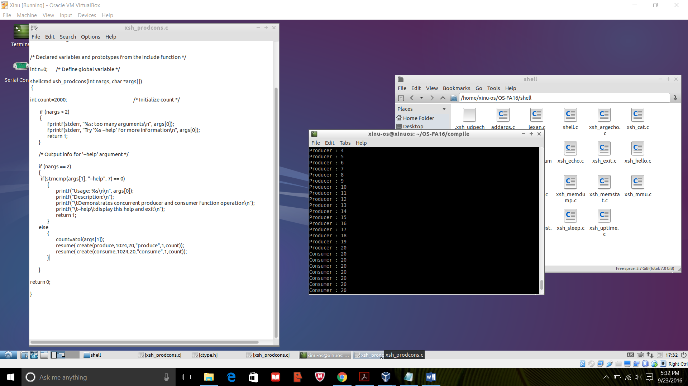

* Dhaval